TWO YEAR OLD
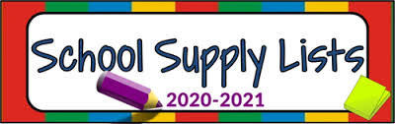

1 - Box of crayons (Jumbo)
1 - Bottle of Elmer’s Glue
3 - Glue sticks
1 - Art smock
1 - Plastic folder (with pockets)

Child’s Personal Needs:

Diapers wipes & ointment
For students own personal use.
2 - Boxes of tissues
2 - Bottle of hand Sanitizer
2 - Disinfecting Wipes

Blanket & crib size fitted sheet (Must fit in cubby box)
2 changes of clothes (school uniform only)
All Bottles or sippy cups must have a TOP.
No book bags
No lunch boxes (Zip lock or Brown bags only)

*Please have all supplies and personal belongings labeled with your child’s name.

Thank you,
2-year-old classroom staff

