ONE YEAR OLD
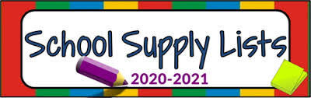
Supply List
1 - Pack of diapers
1 - Wipes
Ointment (optional)
Blankets
1 - Sippy cup with lid
2 - Changes of clothes
Art Smock
Pacifier (if needed)
For students own personal use.

2 – Bottle of hand Sanitizer
2 – Disinfecting Wipes

The child’s extra clothing will be kept in
his/her cubby to use when needed.

*Please have all supplies and personal belongings labeled with your child’s name.

Thank you,
1-year-old classroom staff

